*Latent effects of winter warming on Olympia oyster reproduction and larval viability*

**Authors:** Laura H Spencer1, Erin Horkan2, Ryan Crim2, Steven B Roberts1

1University of Washington, School of Aquatic and Fishery Sciences, 1122 NE Boat St, Seattle, WA 98105, United States

2Puget Sound Restoration Fund, 8001 NE Day Rd W, Bainbridge Island, WA 98110, United States

### Supplemental Materials

**Supplemental Figure 1:** Gonad sex, sperm stage, and egg stage over time by treatment. Adults were in treatments during from Dec 8 – Feb 27 (weeks 0-13), and were in common spawning conditions (high food & temperature) from Feb 28-Mar 23 and were sampled on Mar 13 & 23 (weeks 15 and 16).

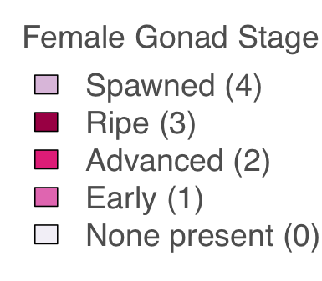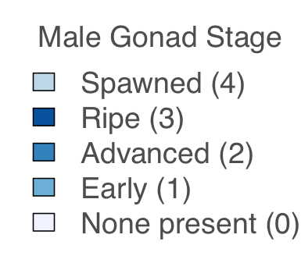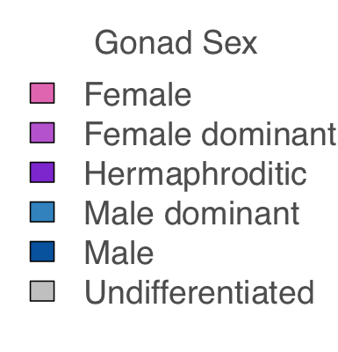

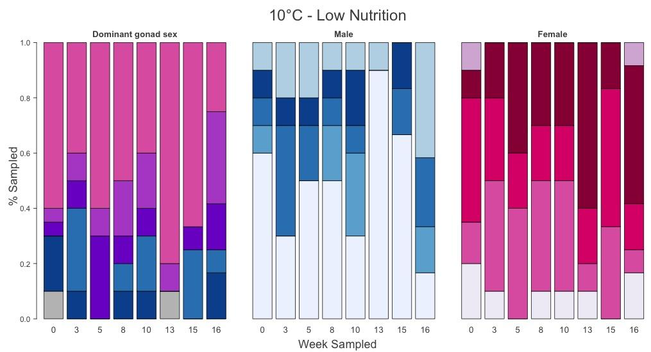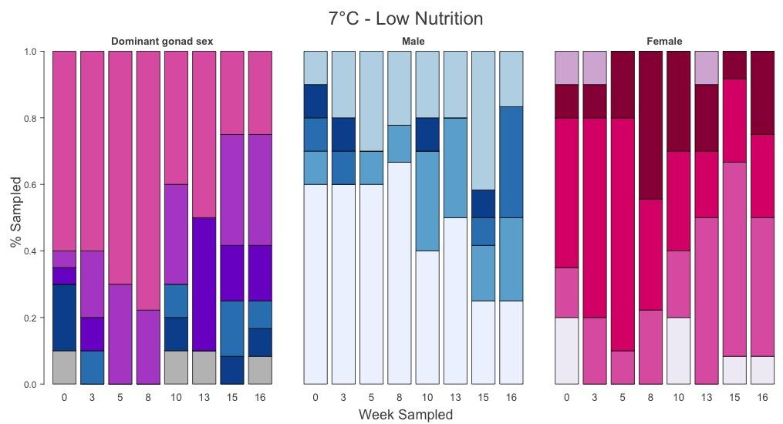



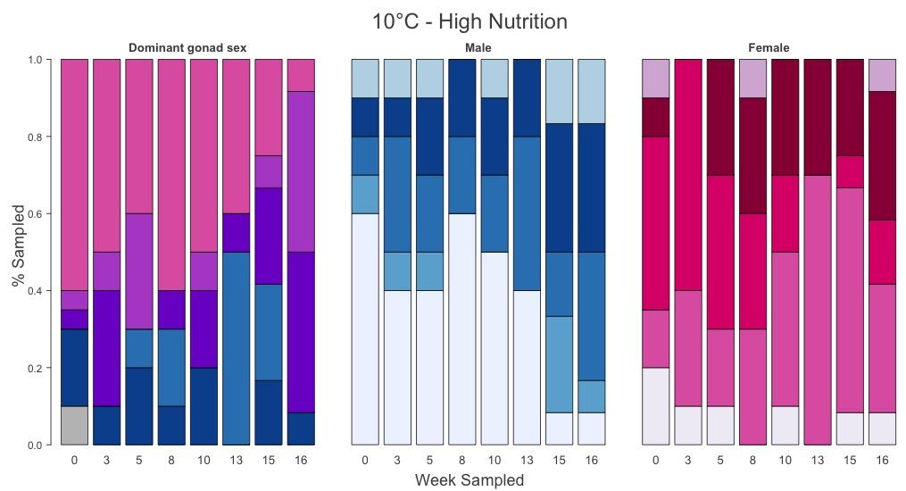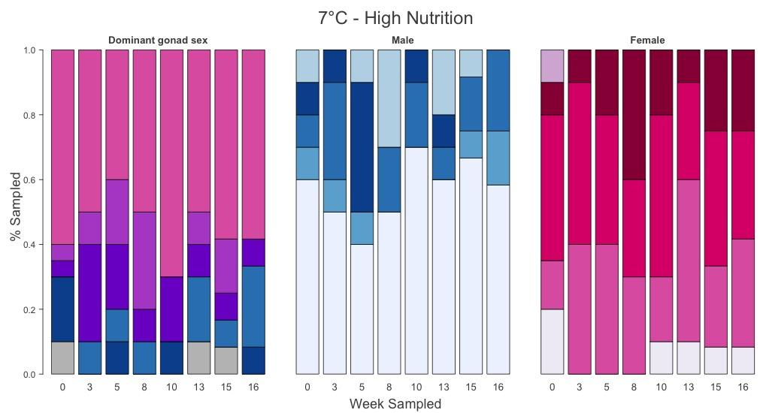

**Supplemental Table 1:** Male gonad stage on Feb 27 differed by treatment (final day of winter treatments, prior to reproductive conditioning), 𝝌2 = 25.8, p=0.0065.

|  |  |  |  |  |  |
| --- | --- | --- | --- | --- | --- |
| Male stage, week 13 only | None present (0) | Early (1) | Advanced (2) | Ripe (3) | Spawned (4) |
| 7C / LOW FOOD | 5 | 3 | 0 | 0 | 2 |
| 10C / LOW FOOD | 9 | 0 | 0 | 0 | 1 |
| 7C / HIGH FOOD | 6 | 0 | 1 | 1 | 2 |
| 10C / HIGH FOOD | 4 | 0 | 4 | 2 | 0 |

**Supplemental Table 2:** Male gonad stage during reproductive conditioning (Mar 13 & 23 combined) differed by treatment, 𝝌2 = 32.2, p=0.0010.

|  |  |  |  |  |  |
| --- | --- | --- | --- | --- | --- |
| Male stage, weeks 15 & 16 | None present (0) | Early (1) | Advanced (2) | Ripe (3) | Spawned (4) |
| 7C / LOW FOOD | 5 | 5 | 4 | 1 | 7 |
| 10C / LOW FOOD | 10 | 2 | 5 | 2 | 5 |
| 7C / HIGH FOOD | 15 | 3 | 5 | 0 | 1 |
| 10C / HIGH FOOD | 2 | 4 | 6 | 8 | 4 |

**Supplemental Table 3:** Larval collection data by adult winter treatment (4 replicate spawning tanks per treatment).

|  |  |  |  |  |
| --- | --- | --- | --- | --- |
|  | 7C - Low Nutr. | 10C - Low Nutr. | 7C - High Nut. | 10C - High Nutr. |
| Mean larvae collected / day | 424,000  365,000  140,000  357,000  = 339,000 (overall) | 364,000  299,000  381,000  197,000  = 304,000 (overall) | 219,000  349,000  448,000  269,000  = 312,000 (overall) | 395,000  261,000  280,000  295,000  = 304,000 (overall) |
| Median larvae collected/day | 168,000  382,000  135,000  229,000  = 212,000 (overall) | 210,000  281,000  419,000  186,000  = 218,000 (overall) | 186,000  457,000  256,000  262,000  = 256,000 (overall) | 319,000  125,000  164,000  184,000  = 195,000 (overall) |
| Max collected | 2,073,000  1,274,000  698,000  248,000 | 1,238,000  915,000  871,000  561,000 | 1,116,000  610,000  567,000  426,000 | 1,190,000  962,000  918,000  677,000 |
| Total larvae released | 5,939,000  3,652,000  1,116,000  2,854,000  = 13,561,000 | 4,729,000  3,583,000  3,427,000  2,561,000  = 14,300,000 | 1,756,000  1,743,000  3,133,000  2,421,000  = 9,053,000 | 3,558,000  2,606,000  3,361,000  3,831,000  = 13,357,000 |
| No. of Broodstock  (at end of collection) | 32, 31. 28, 34  = 125 (sum) | 36, 33, 34, 37  = 140 (sum) | 19, 19, 28, 23  = 89 (sum) | 34, 32, 37, 35  = 138 (sum) |
| Total larvae released, normalized by # broodstock | 185,600  117,800  39,900  83,900  = 106,800 (average) | 131,400  108,600  100,800  69,200  = 102,500 (average) | 92,400  91,700  111,900  105,300  = 100,300 (average) | 104,700  81,400  90,800  109,500  = 96,600 (average) |
| Mortality during spawning | 54 | 36 | 86 | 35 |
| Date of first release | 3/30, 3/30, 3/30, 4/2 | 3/30, 3/30, 3/30, 4/1 | 4/4, 4/4, 4/4, 4/7 | 4/1, 4/1, 4/2, 4/2 |
| Date of max release | 4/4, 4/8, 4/8, 4/8 | 4/4, 4/7, 4/9, 4/25 | 4/5, 4/14, 4/15, 4/20 | 4/2, 4/2, 4/7, 4/8 |
| Date of last release | 4/17, 4/22, 4/25, 4/25 | 4/20, 4/22, 4/25, 4/27 | 4/18, 4/19, 4/20, 4/25 | 4/18, 4/18, 4/22, 4/25 |
| No. big larval release days (>10k) | 13, 9, 7, 8  = 37 (sum) | 13, 12, 9, 12  = 46 (sum) | 8, 4, 7, 9  = 28 (sum) | 9, 10, 11, 12  = 42 (sum) |

**Estimates of female reproduction rate**

The number of adults that reproduced was estimated from the total number of larvae released during the collection period, divided by 215K larvae per female, which was based on prior estimates for *O. lurida* of shell height 35 mm (Hopkins 1936). Recent pair-mating experiments, however, indicate that brood size can range from 100,000 to 500,000 larvae from *O. lurida* of similar sizes (Ryan Crim, unpublished). We therefore did not include the rate of female mating estimates in the main text, but report it here for those who are interested.

The estimated percent of oysters that reproduced as female did not differ among treatments (for temperature, food, and temperature:food, respectively: F(1,12)=0.015, 0.25, 0.11; p=0.91, 0.63, 0.75), and across the 16 spawning tanks was on average 43±13%.



**Supplemental Figure 2:** **Top**: Larval survival (%) by date larvae were released from the brood chamber, color coded by broodstock treatment, showing a positive relationship. **Bottom**: Larval survival (%) by the number of larvae released/collected in that larval group (estimate of brood size), showing a negative relationship.



**Supplemental Figure 3**: **Top**: Larval survival to post-settlement stage ~ variation in larval length within a pulse (upon release). No significant associations or differences among treatments were found. **Bottom**: Variation in larval length within a larval pulse ~ total no. of larvae released.

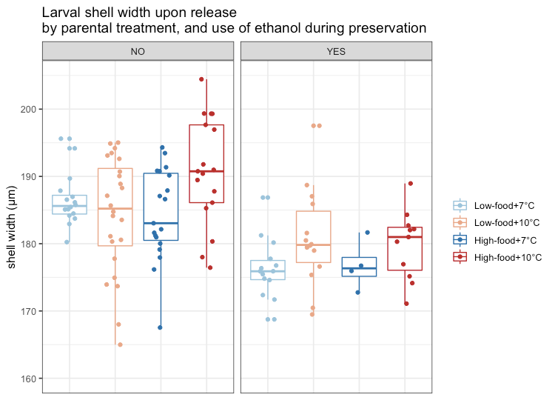

**Supplemental Figure 4:** Larval shell width by parental treatment, and by the use of ethanol during sample preservation. Ethanol use was included as a random effect in the mixed effect model that assessed parental treatment effects on larval shell size. Ethanol was superior at preserving larval tissue, but was unfortunately not used for all samples. Low-food=5k algal cells/mL, and high-food=50k algal cells/mL

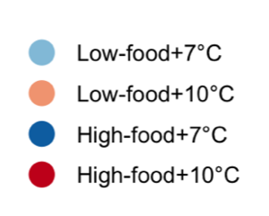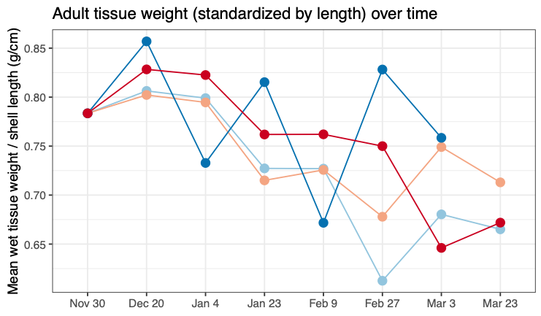

**Supplemental Figure 5:** Adult tissue weight (standardized by shell length), which decreased throughout the winter, with no significant effect of temperature or feeding level.